Polaris: Data Analytics

Assignment 3

Student Name: Tse Kit Yee

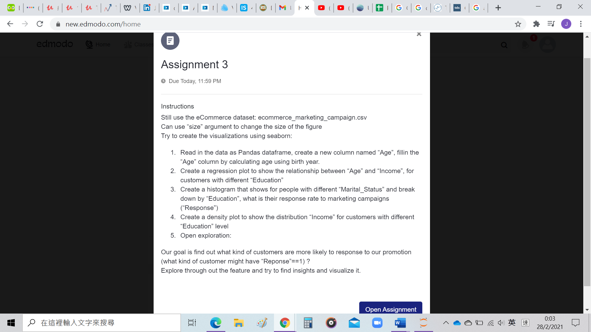

Question 1

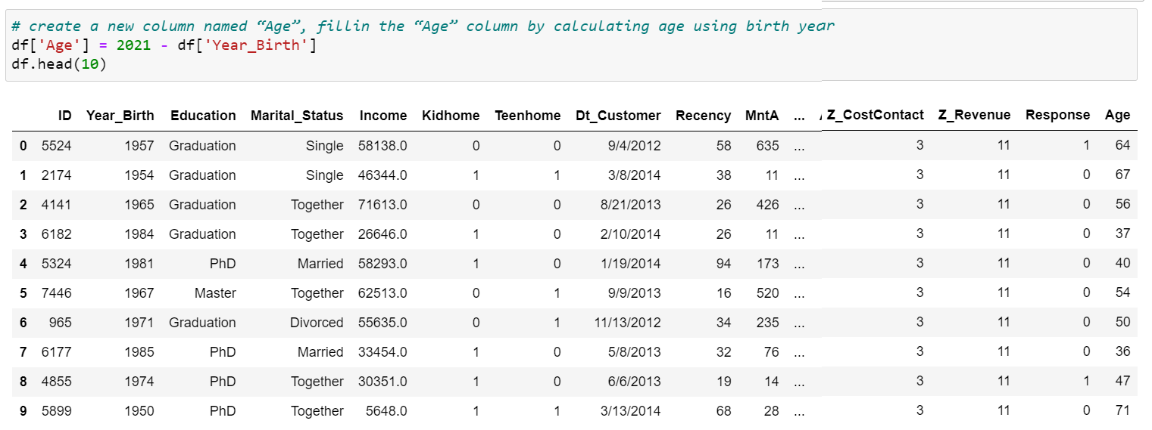

Question 2

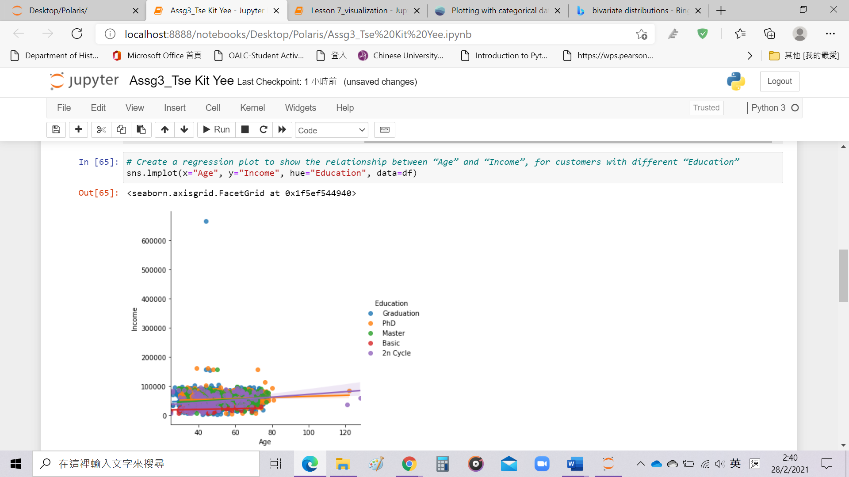

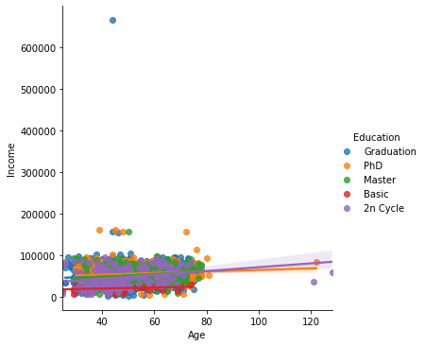

Question 3

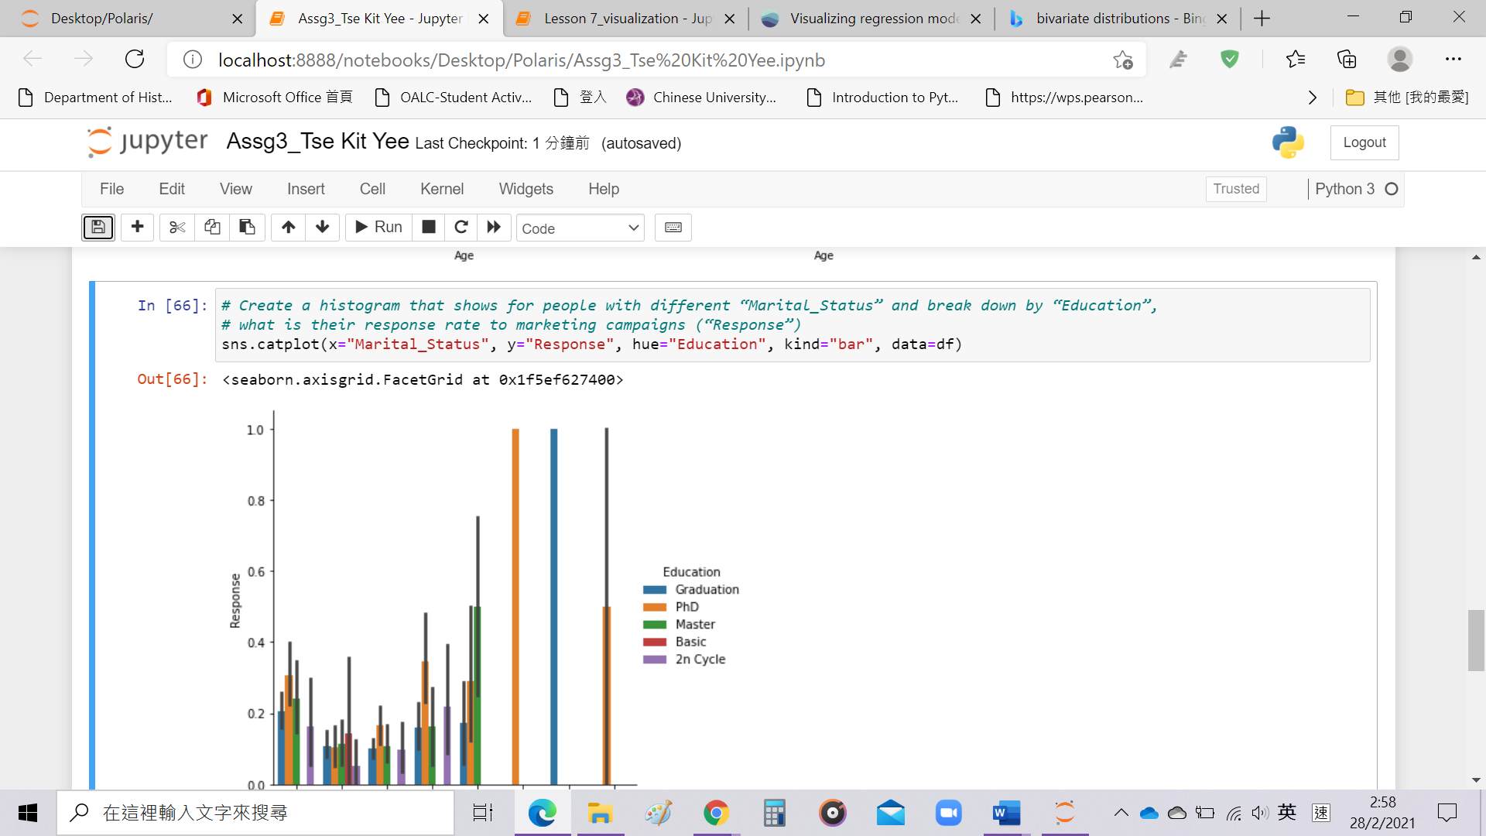

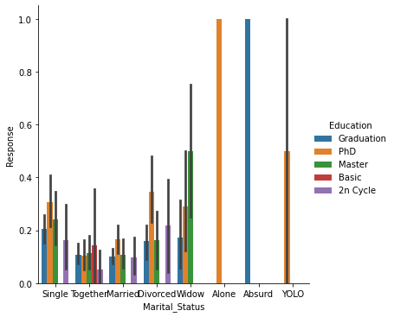

Question 4

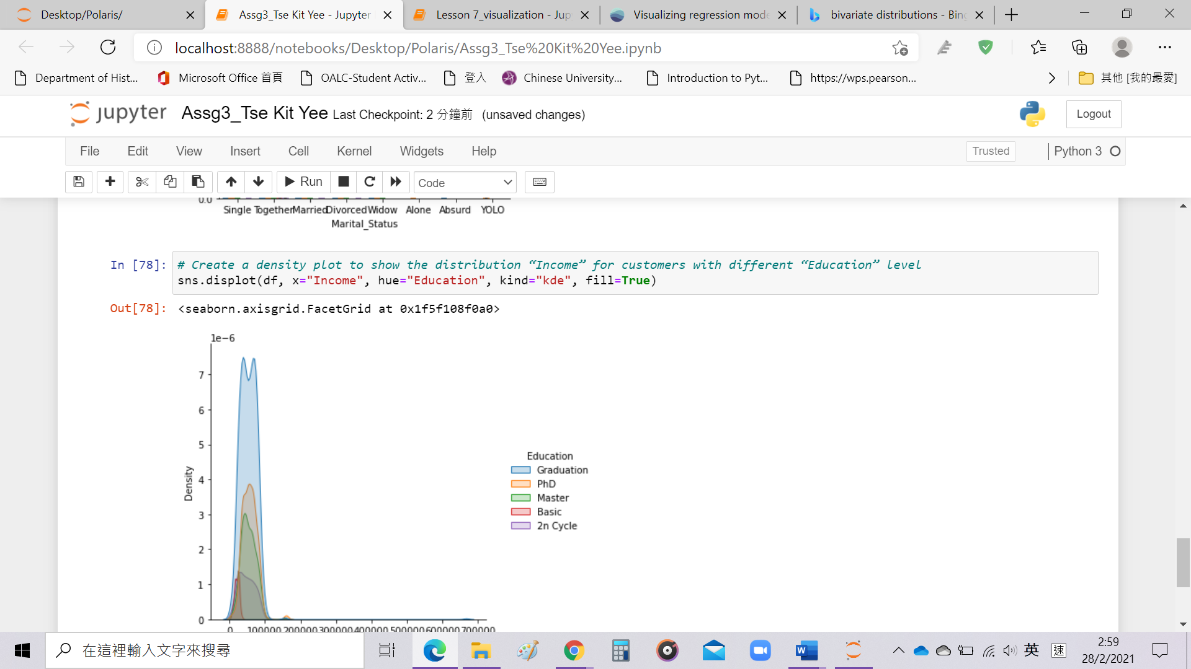

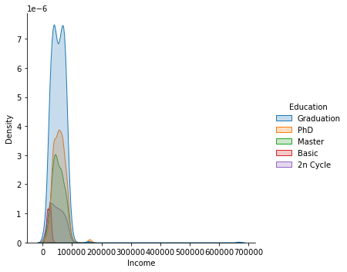

Question 5

Our goal is find out what kind of customers are more likely to response to our promotion (what kind of customer might have “Response”==1) ?

Explore through out the feature and try to find insights and visualize it.

Our propose is to figure out which kinds of customers are more likely to response to company’s promotion. Here, we use Age, Education, Income and Marital Status to find out what types of customers might have “Response”==1.

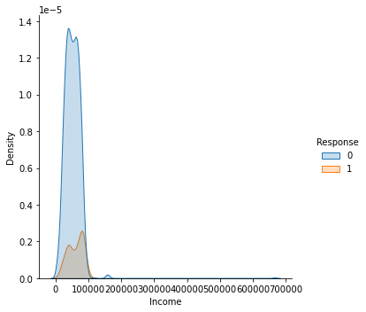

The first kernel density estimation plot shows different education level of customer, they mainly concentrated on income between $0 to $100,000, for the one who have graduated education level, it has higher density value, nearly 1.3.

The second kernel density estimation plot shows a distribution on income mainly. Most people had income between $0 to $100,000 do not have response on the promotion, maybe they think the promotion are not fitting to them. For those mostly response to promotion (orange field in the second graph) contains only round 0.2 density value.

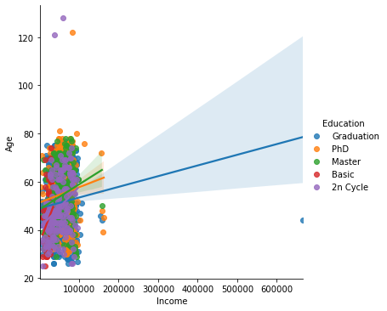 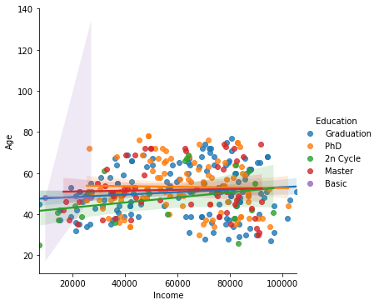

Both regression plots show the relationship between income and age for people with different education level. For the first one, we use original data set, people are concentrated on an area with age 25-80 and income between $0 to $100,000, no matter how high or low their education level are, besides, they response to promotion or not would not be considered.

The second regression plot, we focus on people must response to the promotion, more people with graduated, master and PhD education level have more responses.

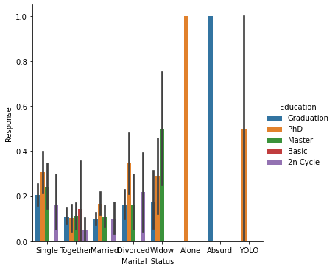

A histogram shows for people with different Marital Status and Education level, what are their response value. For people who are alone with PhD education level and absurd with graduated education level, both have strictly 1.0 response rate. For those who are together with others and married status, they have less response on promotion (only round 0.2 response rate).

To conclude, customers, aged at 25-80, have $0-$100,000 income interval, who are also alone with PhD education level and absurd with graduated education level, are more likely to response to our promotion. For those are widow with master education level and yolo with PhD education level, are quite likely to response to our promotion, it shows around 0.5 response value.